Leung, Cristian K (Student)

Cisco Layer 2 Attacks and Mitigations Lab
MAC Flooding, DHCP Starvation, and ARP Spoof

Purpose:
The purpose of this lab was to learn how to both attack and mitigate using various popular techniques.
Background Information:
In the early ethernet days around 1980s to 1990s all networks were small, local, and trusted. Devices assumed everyone on the network was legit and there was no malicious activity. There was no need for authentication. During 1990s to early 2000s ethernet grew more popular and technology advanced, switches started to be used and networks became more efficient. But with these advancements came network attacks. The first few exploits that arose during this time, for example MAC flooding and ARP spoofing. As networking expanded in the 2000s and networks scaled, attacks became more targeted. DHCP starvation and STP manipulation arose during this time. Now that we’re at present time, we’ve designed a lot of defense mechanisms, for example port security and dynamic ARP inspection. Nowadays most issues come from misconfigurations of defenses.
Layer 2 protocols are inherently vulnerable to attacks due to not having an authentication system or encryption. Most of those protocols like DHCP, ARP, STP were designed for an environment where all devices are trusted and there’s no need to verify the identity of device sending messages. As a result of this as technology became more advanced people were able to take advantage of the design of layer 2 and can impersonate legit devices, manipulate traffic flow, or disrupt services without needed special access.
MAC flooding is a technique that floods out sham MAC addresses to overwhelm a switch’s CAM table, to the point where the switch cannot identify a destination and floods out to every port, allowing attackers to view and capture sensitive packets.
ARP spoofing is an attack that repeatedly sends out fake ARP messages. This essentially tricks the devices into sending traffic to the attacker instead of the real destination.
DHCP starvation exhausts the DHCP addresses by flooding the server with fake requests using spoofed MAC addresses. This stops the victim from being able to get an ip address leading to no internet access and the network appearing down.

Topology:
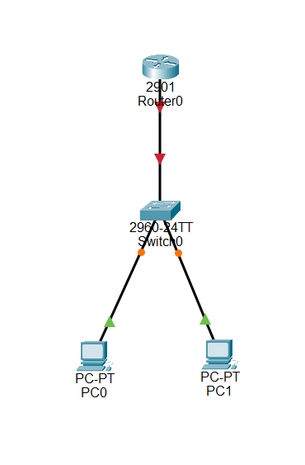
Lab Summary:
For this lab we had to first install Linux Mint. Other Linux Distros or Virtual Machines should also work for this lab. To install go to the website and follow installation instructions, once you finish you can begin the lab.
First step is to setup DHCP on a router. Use the following commands to do this:
!
hostname R1
!
ip dhcp excluded-address 192.168.1.1 192.168.1.10
!
ip dhcp pool LAN
network 192.168.1.0 255.255.255.0
default-router 192.168.1.1
!
interface G0/0
ip address 192.168.1.1 255.255.255.0
no shut
!
Next go to control panel and configure your ethernet port your using to receive addresses from DHCP
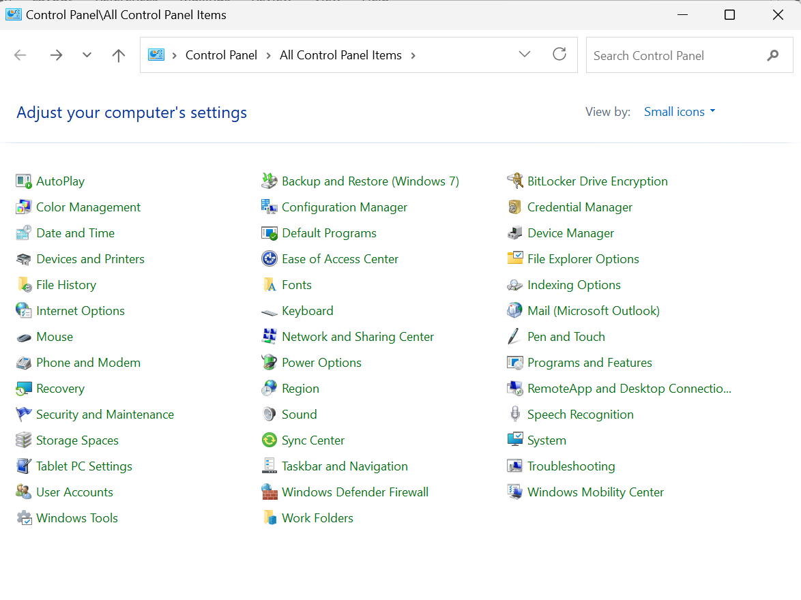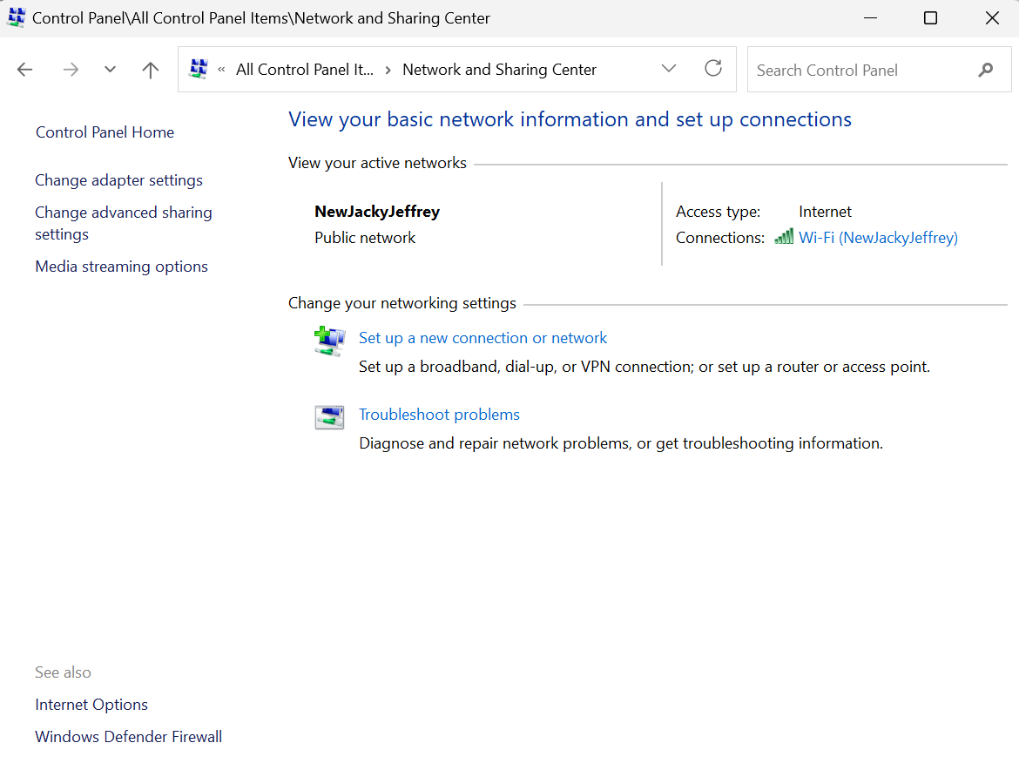
That’s the setup now we can start.
MAC Flooding
In Linux open the terminal and install Dsniff with the following command:
~$ sudo apt install dsniff
To start flooding MAC addresses use the next command:
~$ sudo macof or ~$ sudo macof -i eth0 (or whatever interface)
IMPORTANT: Use CTRL-C to stop the attack/command. Traffic should now be flooding throughout the port. To see the attack use WireShark. Check the CAM table to see the MAC addresses bound to the switch.
When MAC flooding is active, when victim’s PC attempts to ping the router, the PC you use to attack should be able to see the packets captured in their PC without any connections to the victim PC.

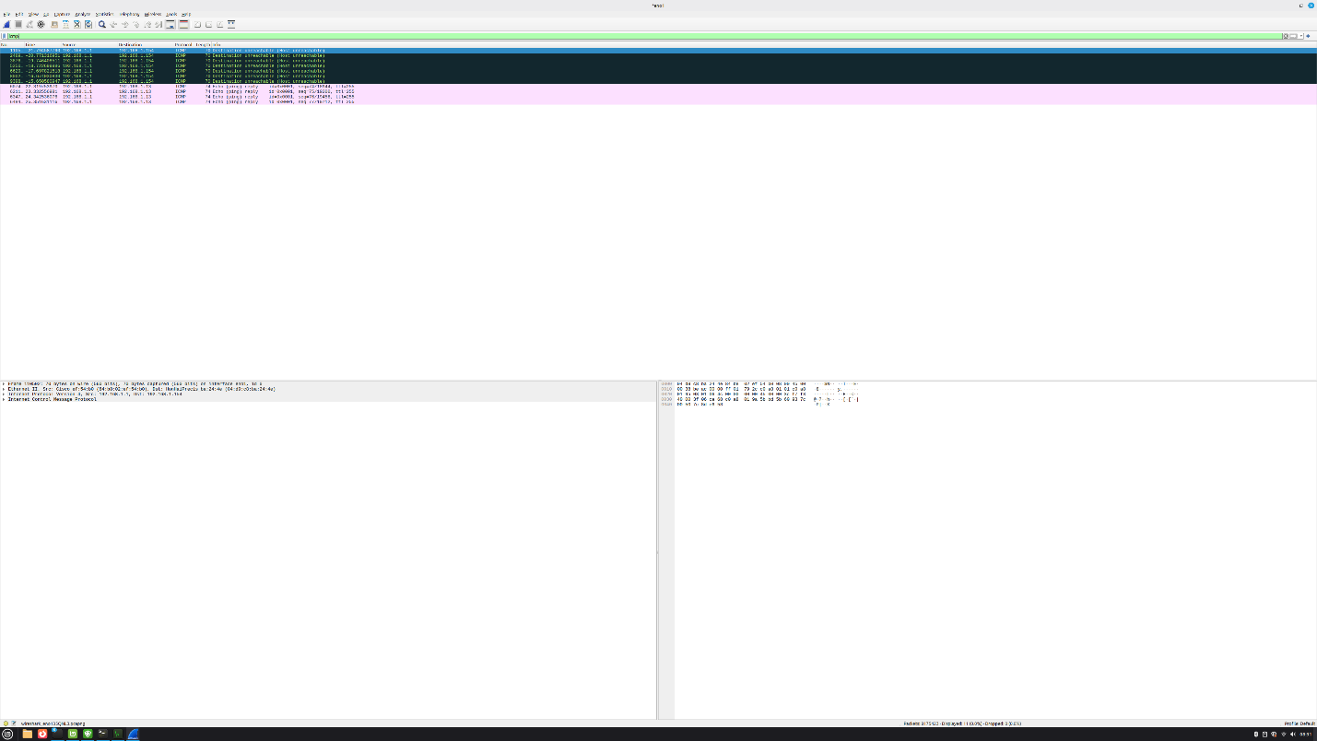
Mitigation:
To mitigate MAC flooding use port security on the switch and set a max number of MAC addresses to the port. Follow the commands below:
hostname S1
!
int fa0/1
switchport mode access
switchport port-security
switchport port-security maximum 5
switchport violation shutdown
!
Arp Spoofing
Open Linux terminal and install dsniff with following command:
~$ sudo apt install dsniff
Afterward configure port forwarding:
~$ sudo sysctl -w net.ipv4.ip_forward=1
Then use this command to start the attack:
~$ sudo arpspoof -i eth0 (interface) -t 192.168.1.13 (Victim PC IP) 192.168.1.1 (Default Gateway IP)
Check arp table to verify that the attack is working. To find this go to command prompt on victim PC and use following command:
Arp -a
The MAC address on default gateway should be different before and after the attack. And you shouldn’t be able to ping the default gateway during the attack.
Mitigation
To mitigate this attack use ARP inspection and DHCP spoofing. These are configured on the switch and untrust all ports other than the guaranteed reliable ports.
hostname S1
!
ip dhcp snooping
ip arp inspection
int fa0/1 (trusted port)
ip dhcp snooping trust
ip arp inspection trust
!
int fa0/2 (untrusted port)

!
ports are inherently untrusted. Manually configure otherwise.

DHCP Starvation
Open Linux terminal and install DSniff with this command:
~$ sudo apt install yersinia
Next use this command
~$ sudo yersinia -I
Your screen should look like this:
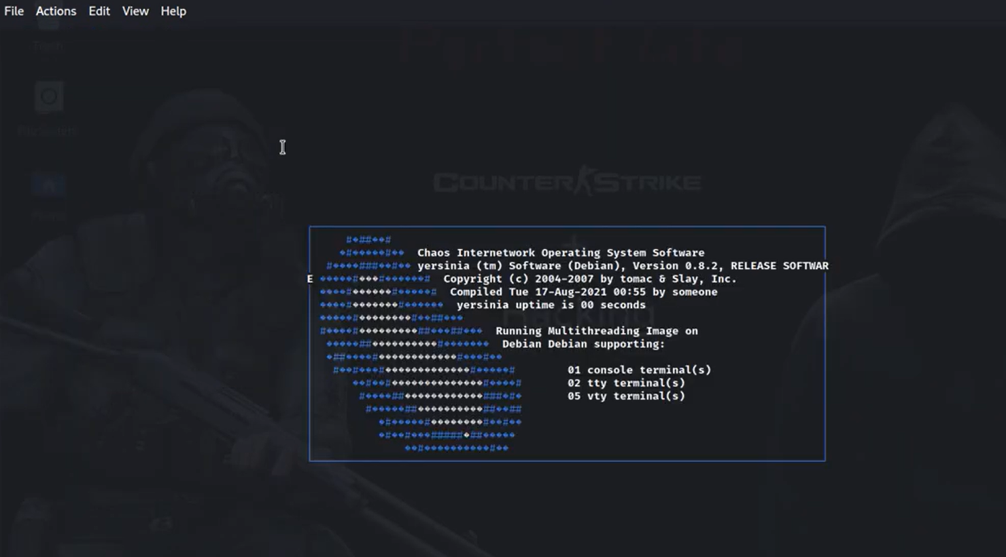
Use to view the help menu and see command list. 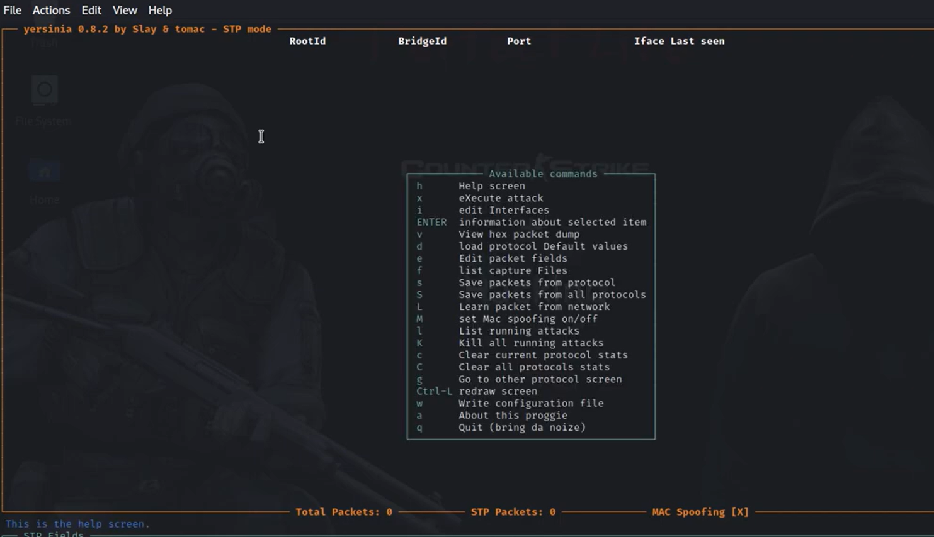
Press g to go to the protocol menu and navigate to the DHCP protocols option.
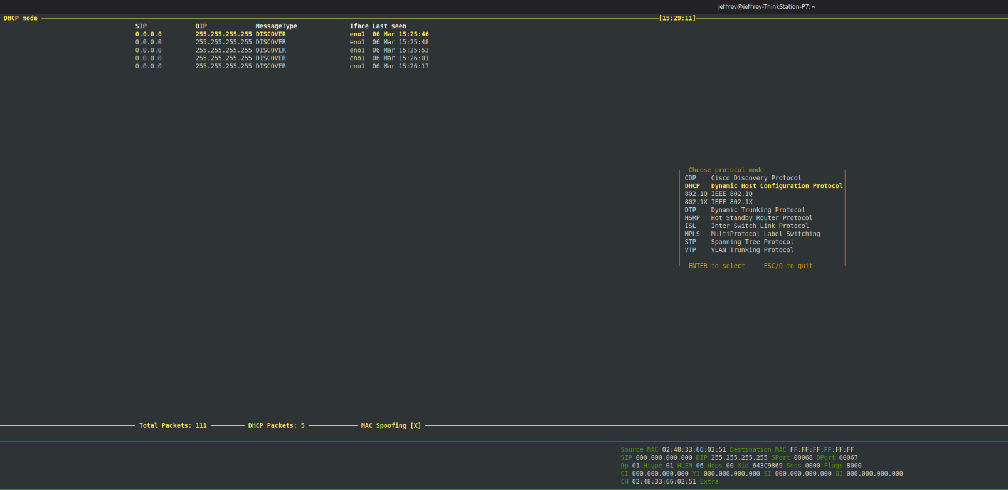
Select DHCP Starvation and then start the attack.
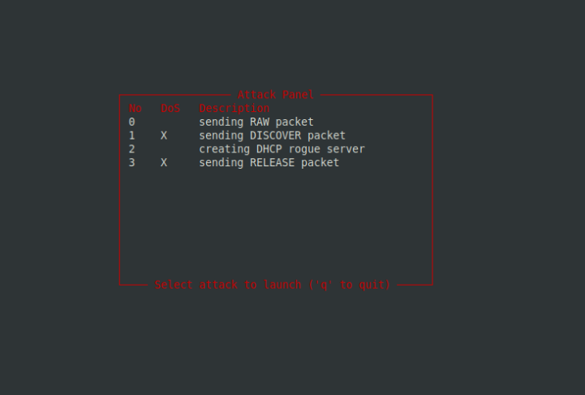
After this you should be able to see a bunch of DHCP packets in wireshark on the victims PC. You can use the following command on the router to see DHCP addresses being used up.
show dhcp binding
Mitigation
To mitigate this attack configure port security or arp inspection and DHCP snooping, in the switch.
hostname S1
!
ip dhcp snooping
ip arp inspection
!
int fa0/1 (Trusted port)
switchport mode access
switchport port-security
switchport port-security maximum 5
switchport violation shutdown
ip arp inspection trust
ip dhcp snooping trust
!
int fa0/2 (Untrusted port)
switchport mode access
switchport port-security
switchport port-security maximum 5
switchport violation shutdown
!
After doing these commands when you attack it should automatically shutdown the port where the attack came from.
Problems
A good chunk of the issues we ran into were because we were impatient and didn’t wait long enough for attacks/mitigations to show results for example we thought DHCP was broken but it was just restarting after we stopped the DHCP spoof attack. We figured it out after testing it lots of times. Another issue we had was that on Linux if you run some of the attacks for too long the VM just crashes. This was pretty annoying so we had to make sure to stop it every once in a while when testing. Also we got stuck because the VM was glitching and the cursor wasn’t showing. We had search on forums and tried several methods eventually fixing the settings. Otherwise things went pretty smoothly, sometimes if a certain
Conclusion
This lab was pretty insightful and showed how easy it was to attack a unprotected network. It also taught us the steps to preventing these attacks and how you should setup every network with protection. Overall it was really intresting to see these attacks in action as we’ve learned about them but never actually performed them before.

